Dear Customer/Owner:
Groton Electric is one hundred and one years old and continues to serve the ratepayers of Groton with stability and reliability. Over the past twenty years, GELD has been working with the Town on the Station Avenue redevelopment plan and it appears it is finally moving forward. In late 2010, GELD purchased the land adjacent to the current office facilities and began the RFP process for the design and engineering services of our new office and garage facilities. GELD plans to relocate away from the rail trail set back on Station Avenue. The land along the rail trail will be declared surplus when an adequate offer is received from a future developer and the area may become a downtown mixed-use village.
As always, our mission remains intact “to provide power at the highest degree of reliability that fiscal prudence dictates.” This means low rates, high reliability, and great customer service for the ratepayers of Groton.
Capital Improvements
Our Automated Meter Reading (AMR) system is now 99.5% deployed – the commercial AMR meters were installed in the fall of 2010 and only a handful of extremely old-style meters need to be replaced. This system allows customers to track their usage online and make adjustments in their electric use, if needed, during periods of peak demand. It also allows for up-to-the-minute outage information.
The GIS (Geographic Information System) software was upgraded and will assist employees to locate any asset owned by GELD (transformers, poles, lines, meters, switches, re-closers, etc.) – it will also be integrated into the outage management system that is already in place through our smart meter vendor and will help to pinpoint specific areas of concern regarding outages.
In addition to upgrading commercial meters and GIS system, we replaced the antiquated underground cables running along Route 40 crossing Route 119 and down Broadmeadow Road. By replacing equipment that has served its useful life, our infrastructure is enhanced and reliability is increased. Over the next several years, it will be our goal to replace the oldest underground cables throughout town.
Power Supply
To maintain our position with rates lower than 97.4% of households in Massachusetts, it is important for GELD to have a diversified power portfolio – our approximate 2010 power mix consisted of 44% nuclear, 31% natural gas, 9.5% hydro-electric, 9% coal, 4.5% other renewable, 1.1% oil and .9% pump storage.

Stable and decreasing natural gas prices throughout 2010 translated to lower power costs for the electric industry and stable rates for Groton Electric ratepayers. Unfortunately, transmission costs continue to increase – the decreases in natural gas prices helped to offset the transmission increases. In an effort to ensure stability, GELD secured small strips of power at reasonable prices for most of 2010 through 2011 and continues to monitor the natural gas prices to purchase power at the best value for the ratepayers for 2012 and beyond.

The construction of the Berkshire Wind Power Project towers and turbines was completed in 2010; however, there were several challenges that have delayed the project from beginning to produce electricity. We are hoping that power will be generated soon and GELD will receive 5.5% of the renewable energy output when the project is up and running.

Growth Trends
Our rates remain lower than most utilities in Massachusetts even though we have an extremely small commercial base. The peak usage in 2010 was in the month of July and was the fourth highest monthly peak since we began keeping records in 1909.

Because our peak typically occurs in the summer, GELD initiated a demand response pilot program that targeted customers with central air conditioning. The goal is to reduce Groton Electric’s transmission and capacity payments by reducing our contribution to the peak-hours for the New England region and to pass the savings onto the customers that participate in the program.

Even though the economy is slow to recover and Groton residents have been conserving energy, the extra warm summer and fall of 2010 resulted in Groton’s kilowatt-hour sales increasing by 3.7% for the year. KWh sales had been trending downward for the previous three years.

New construction began picking up in 2010. Our customer count increased by 41 new services and we mailed out 4570 bills at the end of the year.

The graph below indicates that our number of customers is leveling out after decades of rapid growth.

Service & Reliability
We take great pride in our high level of service and commitment to reliability. It is always our highest priority to respond promptly to interruptions in service and to restore power in the most expeditious and safe manner, no matter the weather or the hour.

We begin with a stable and solid foundation due to years of prudent management, but we continue to upgrade and improve the infrastructure to help the reliability of our distribution system. We recently installed switchable capacitor banks which improve our power factor, we upgraded the low side breakers at our substation to improve reliability, we added single-phase re-closers in an effort to isolate outages to smaller areas (less customers without power) and we have been proactively replacing antiquated underground services throughout town and undertook a major project in 2010 to upgrade the underground at the intersection of Routes 119 and 40.

We also trim trees for the safety and reliability of our distribution system. We have contracted with a local certified arborist to aggressively trim throughout town in an effort to eliminate trees or branches that are potential safety hazards or could cause service reliability problems. The contractor only removes trees that are or will become a direct threat to our distribution system.

One of the factors that contributed to the decrease in the number of outage hours is the increased tree-trimming. The number of outages increased from 61 in 2009 to 104 in 2010; however, the total number of customer outage hours decreased significantly – in fact the outage hours are lower than 2009, 2008 and 2007 and are 21% lower than our average for the last ten years.
Financial Highlights
For 2010 we earned a net income of 2.6% of plant value. Our plant value continues to increase due to our infrastructure enhancements. Rates remained stable throughout 2010 even though transmission costs are increasing – decreases in natural gas prices helped to offset transmission increases. Unfortunately, the transmission costs are expected to rise over the next several years. We continue to offer a 10% discount to customers who pay their bills by the 10th of the month and a double discount on the November 30 bill to celebrate the holidays. This policy encourages customers to promptly pay and helps contribute to another year of record low arrears. We finished the year with the seventh lowest rates out of 42 Massachusetts utilities for the average 750 kWh electric user. The two investor-owned utilities that service the surrounding towns, National Grid and Unitil, have rates that are 21% and 61% higher than Groton Electric respectively.
As manager, I appreciate the leadership and support of Commissioners Christie, Hersh and Lindemer. Their sincere concern for the ratepayers is evident in every decision they make. I’m sure the Groton ratepayers are thankful for the stability and unsurpassed customer service their locally owned and operated light department provides day in and day out.
Sincerely,
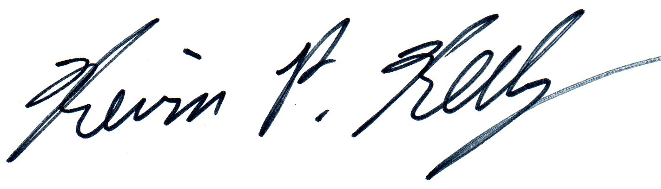

Kevin P. Kelly
Manager

